Be a Science Alliance Buddy
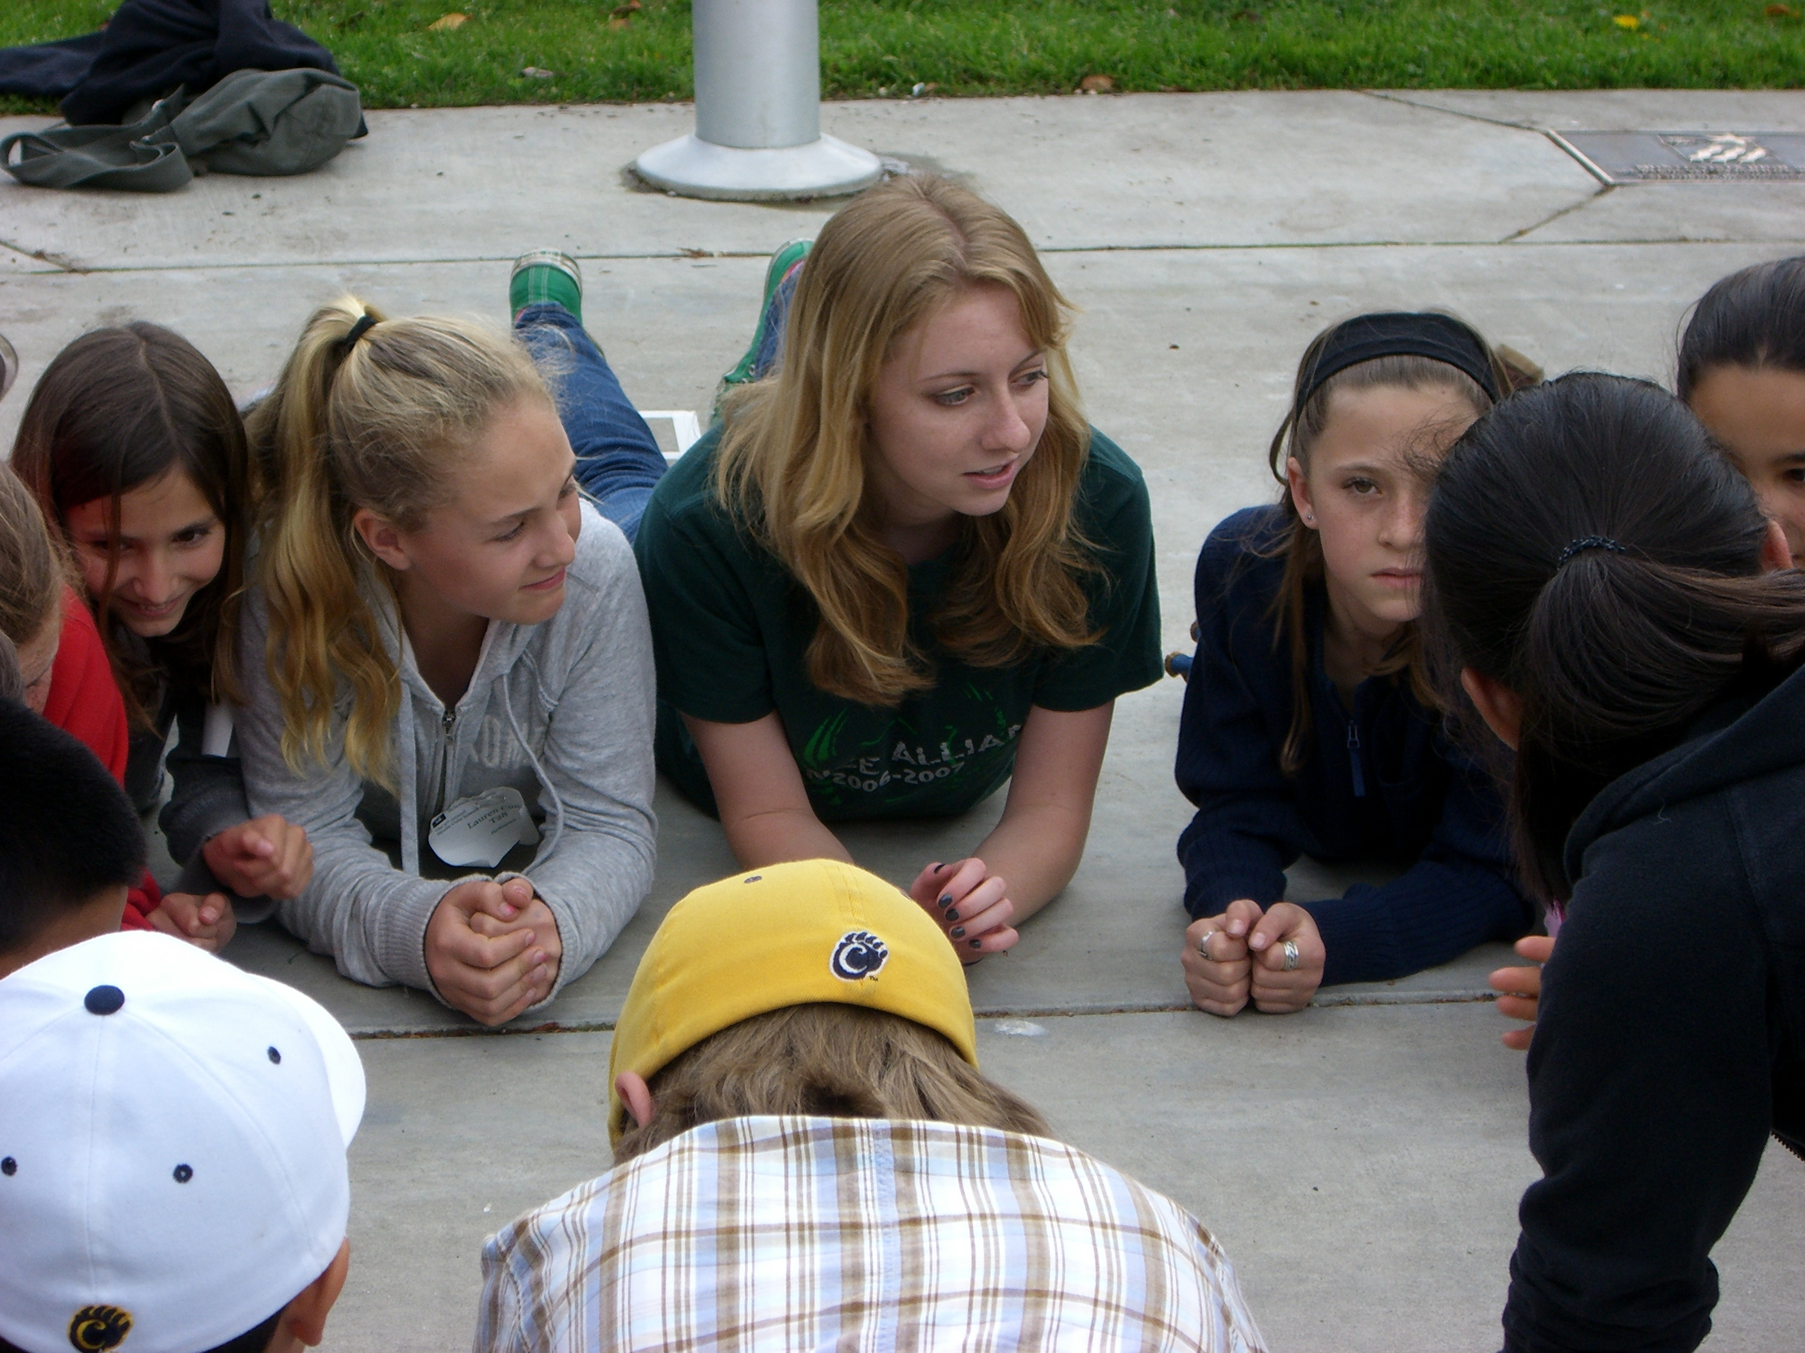
Has your 5th grade teacher assigned you to do a science fair project? Do you want to get ready for middle school science? Do you want to do a science project on your own for the enriching experience? Do you need EXPERT help? Either way …Science Alliance Club is here to help you!!

Join Science Alliance for a time of excitement and scientific discovery.

When you join you’ll be given a high school mentor from Monte Vista, San Ramon or Dougherty Valley High School to help you with every step of the science project!! You can work alone, or in a group of 2 or 3 of your friends. Working with your high school mentor you will design and carry out your own science experiment, and have fun at once a month after-school meetings at either Monte Vista or San Ramon Valley High School where you will meet with your high school science mentor to discuss and work on some part of your science project. Each meeting involves a theme like the Holiday Cookie Exchange, the Pop Corn Extravaganza or the Ice Cream Social, Pizza Party and more. Science IS Fun!

The High School mentor will also be in touch with you & your parent a minimum of twice a week via email or in person to help you with the various parts of a science research project from November through April.

If your own schools science fair is earlier than April, no worries, our mentors will help you get ready for that fair and then you’ll also come to the District wide 5th grade fair to show off your project on April 24, 2010.

You will participate in a District-wide 5th grade science fair & science fun day on April 24th 2010 put on entirely by the Science Alliance Club.

Be an elite member of this mentorship club that has been recognized state and nation wide for its unique mentoring experiences and many accomplishments.

If you think you want to be involved attend ONE of the MANDATORY Parent information meetings with one of your parents at Monte Vista High School.
Dates: September 29, 30, October 6, 8
Times 3:45-4:45
Where: MVHS student commons (follow the signs on campus
Questions?? Contact pcarothers@mvhigh.net Patti Carothers, Monte Vista High School Science Alliance Advisor.

